**Year 7**

**Maths Booklet**

**Name:**

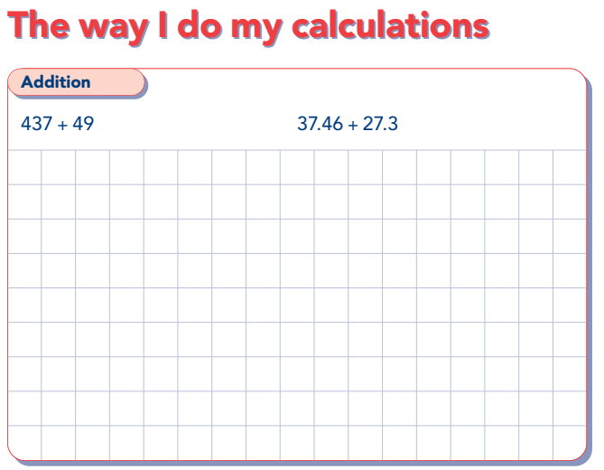

**Calculations**

|  |  |  |  |
| --- | --- | --- | --- |
| **A**  2 + 6 | **B** 12 + 24 | **C** 91 + 81 | **D** 74 + 28 |
| **E** 98 + 55 | **F** + 33 = 97 | **G** 179 + 361 | **H** 894 + 317 |
| **I** 520 +=844 | **J** 3.1 + 5.2 | **K** 3.5 +=4.8 | **L** 12.45 + 7.46 |
| **M** 35 + 45.67 | **N** 5.1 + 7.12 + 15.8 | **O** 26.74 + 58.3 | **P** 63.8 + 23.71 + 5 |

**Worded Problems**

1. If the Eifel tower is 298m tall and the London Shard is 309m. What is their combined height?
2. James has £467 in the bank, he pays what is left of his birthday money to it. If he pays in his £45.57, how much does he have in total?
3. Ryan goes shopping. In the first shop he spends £66.73, in the second £25, the third £156 and £14.56 in the last shop. How much money does he spend total?

**Spot the mistake.**

|  |  |
| --- | --- |
| + 238  1487  3867 | + 238  526  754 |
| + 5  2.3  2.8 | + 438  21.6  65.4 |

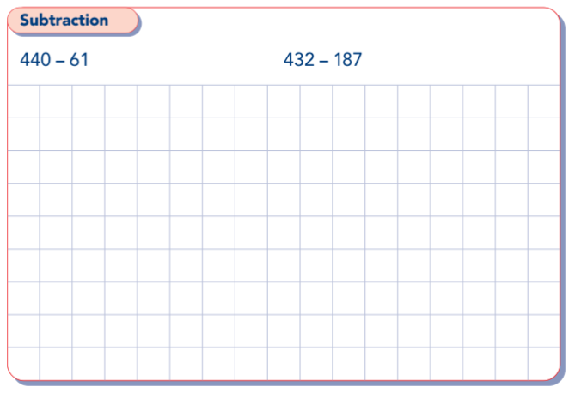

**Calculations**

|  |  |  |  |
| --- | --- | --- | --- |
| **A**  8 - 3 | **B** 36 - 24 | **C** 47 - 18 | **D** 74 - 56 |
| **E** 100 - 58 | **F** - 33 = 45 | **G** 798 - 268 | **H** 1012 - 389 |
| **I** 844 -= 541 | **J** 8.7 - 6.5 | **K** 3.5 -=1.2 | **L**  - 3.6 = 9.7 |
| **M** 74.63 – 17.21 | **N** 6 – 2.4 | **O** 78.54 – 13.6 | **P** 586 – 85.31 |

**Worded Problems**

1. The London Eye is 117m tall and BT tower is 190m tall. How much taller is the BT tower than the London Eye?
2. If the distance from Cardiff to London is 172miles and Amy has driven 87 miles. How many miles has Amy got left before she reaches London?
3. Alex is checking the addition of 2 numbers. The ANSWER is 843, one of the numbers is 591, what is the other number in the sum?

**Spot the mistake.**

|  |  |
| --- | --- |
| 6783-  47  2383 | 567 –  138  431 |
| 83.69 –  782.7  54.2 | 8532-  23.1  830.1 |

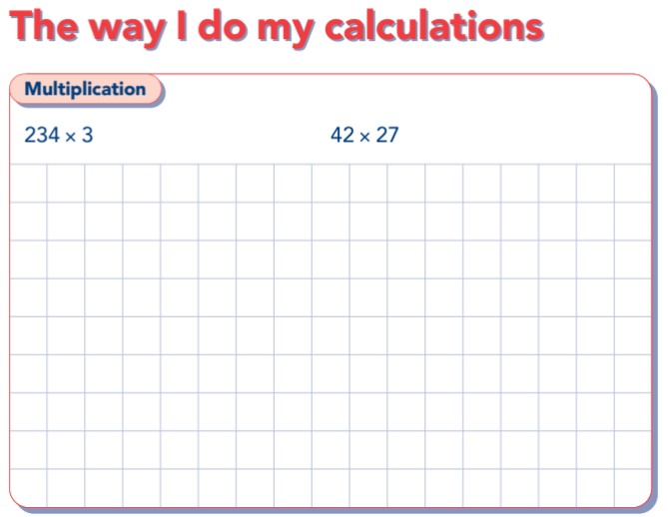

**Calculations**

|  |  |  |  |
| --- | --- | --- | --- |
| **A**  8 x 7 | **B** 12 x 10 | **C** 11 x 12 | **D** 134 x 2 |
| **E** x 4 = 56 | **F** 361 x 5 | **G** 426 x 4 | **H** 243 x = 486 |
| **I**  672 x 7 | **J** 2456 x 5 | **K** 24 x 12 | **L** 68 x 47 |
| **M** 384 x 67 | **N** 34.5 x 3 | **O** 57.24 x 3 | **P** 465.78 x 8 |

**Worded Problems**

1. How many days in 17 weeks?
2. If eggs are packed in boxes of 6. How many eggs altogether in 248 boxes?
3. Dylan gets paid £5.75 every evening to do a paper round. How much does he earn if he competes the round every evening in May?

**Spot the mistake.**

|  |  |
| --- | --- |
| 45x  3  1215 | 85.35 x  6  51210 |
| 38.4x  6  23.04 | 352x  4  1409 |



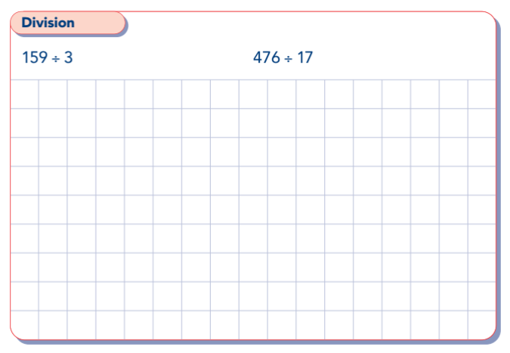

**Calculations**

|  |  |  |  |
| --- | --- | --- | --- |
| **A**  8 ÷ 2 | **B** 35 ÷ = 5 | **C** 36 ÷ 9 | **D**  ÷ 7 = 8 |
| **E** 72 ÷ 3 | **F** ÷ 8 = 13 | **G** 130 ÷ 10 | H 168 ÷ 7 |
| **I**  52 ÷= 4 | **J** 258 ÷ 8 | **K** 121 ÷=11 | L 1655 ÷ 5 |
| **M** 2392 ÷4 | **N** 12.45 ÷ 5 | **O** 145.18 ÷ 2 | **P** 6205.35 ÷ 3 |

**Worded Problems**

1. James, Simon and Angela win £771 between them in a draw. How much money do they each get?
2. 3600 football supporters want to go to an away game together. A coach holds 50 passengers. How many coaches would they need to all go to the game?
3. Fin buys sherbet straws from the newsagents. They cost 4p each and he spends £1.12. How many straws has he bought?

**Spot the mistake.**

|  |  |
| --- | --- |
| 201  3 623 | 1095  5 547.5 |
| 31  3 903 | 14  9 135 |